The commands are executed and comment lines are added which describes the action of the command.

**Commands:**

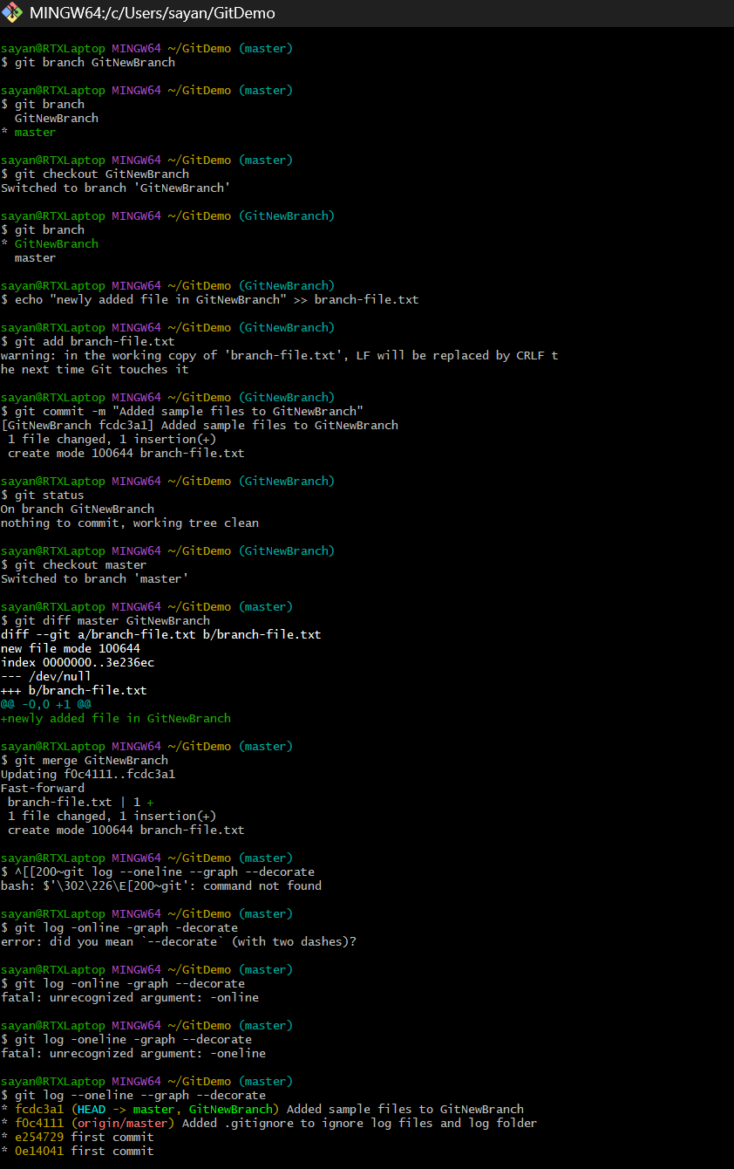

//Creating new branch

//Checking new branch

//Switching to new branch

//Creating new file in branch

//staging the file in branch

//staging the file in branch

//status of branch

//switch back to master

//listing the differences

//merge the new branch

//log

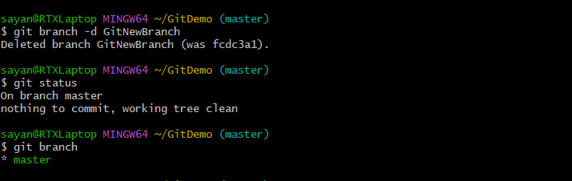

//delete new branch

//check status

//only one branch

**Using P4Merge tool to list out the differences,**

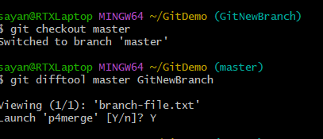

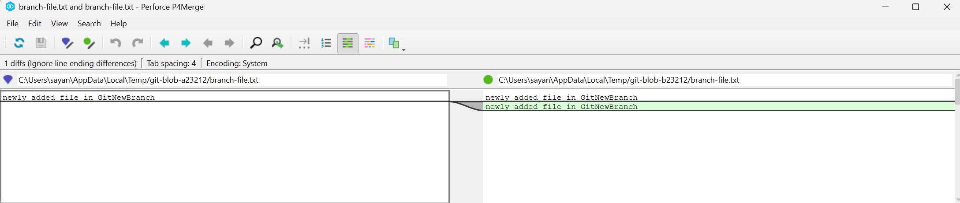**P4Merge**